Method: Traditional 32mm Construction



**Materials:**

All ¾ construction with ¼ back set inside ¾” nailer.

**Material Templates**

www.mozaiksoftware.com

*Optimized for flat panel processing*

*Requires secondary horizontal drilling.*

This construction method is for frameless 32mm construction, assembled with dowels. Bottoms, Tops, & Fixed Shelves dowel into the ends, screws are applied to Unfinished ends – Rafix KD fasteners are applied to finished ends.

Adjustable shelves, hinge plates, and drawer guides all align in the 32mm system holes. Mozaik is set to bore only the required holes, with 5 holes per adjustable shelf.

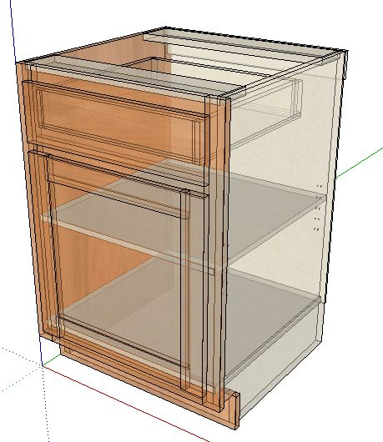

**Part Operations.**

Case Parts.

Dado Depths.

Back is fully captive into End panels ¼”

Adjustable Shelves.

3/16” clearance

**Machining Specifications**.

Nested Based Router Setup.

Tool #1 3/8 compression spiral (Outline tool)

Tool #2 3/8 down shear bit (dados/pockets)

Tool #3 1/4 down shear bit (back dados)

Tool #4 1/2 down shear bit (3/4 dados/pockets)

Drills 5mm for shelves

8mm for dowels.

(If no boring block, place a 5mm bit into Tool #5 & 8mm drill into Tool #6)

Page 2 www.mozaiksoftware.com